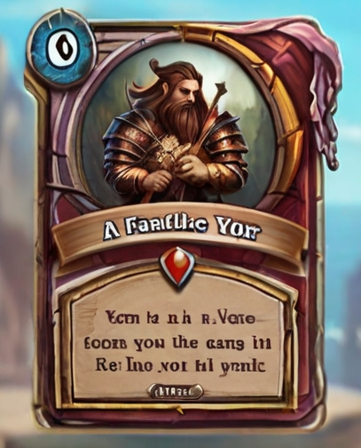
AI generete kort som kan være til inspirasjon:
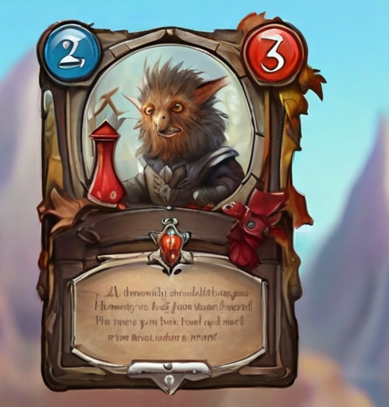
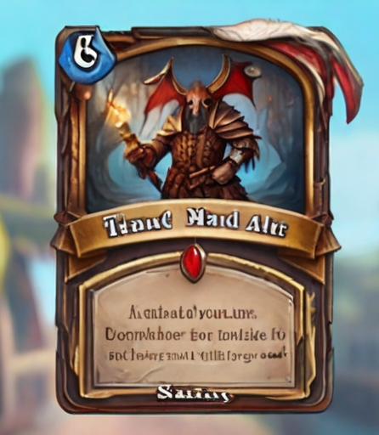

Atheist:
Unite
Cost: 2 gold
Attack: 10
Health: 100
Text: Immune against spells
Sitat: My faith is the right one
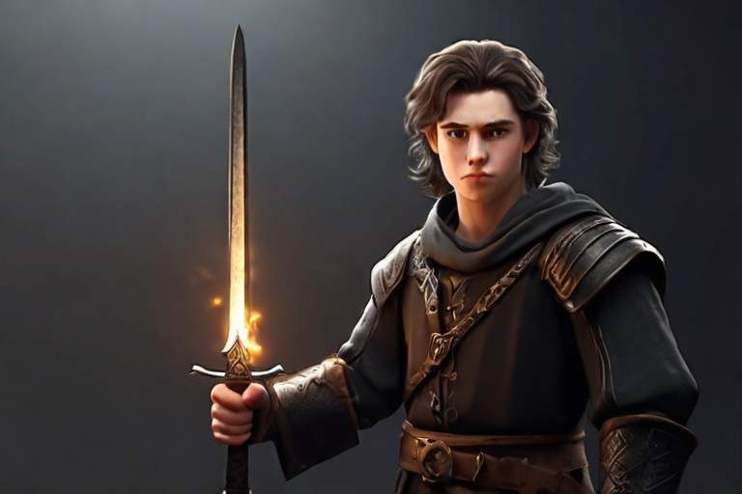

Peacefull warrior:
Unite
Cost: 3 gold
Attack: 0
Health: 300
Text: Allies can not go past this unite
Sitat: I am here to protect
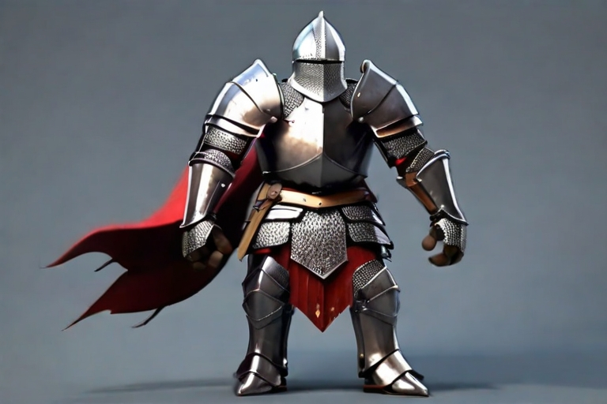
Brothel:
Tower
Cost: 5 gold
Health: 500
Text: Makes a enemy unite pay a golden coin and immobilize them for 10sek. Can only be attacked by non-customer (max one customer).
Sitat: A good night for golden coin
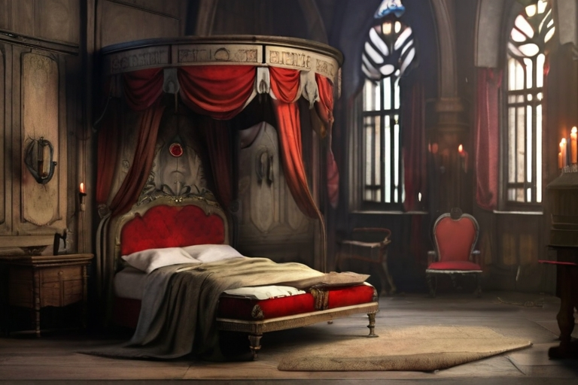
Damsel in destress:
Unite
Cost: 3 gold
Attack: 0
Health: 100
Text: Gives surrounding unites 30% attack speed, and transfers damage to a unite close by.
Sitat: I need a hero!

Homesick warrior:
Unite
Attack: 20
Health: 200
Text: Stops walking forward when there are no towers ahead of his path
Sitat: There is no place as home
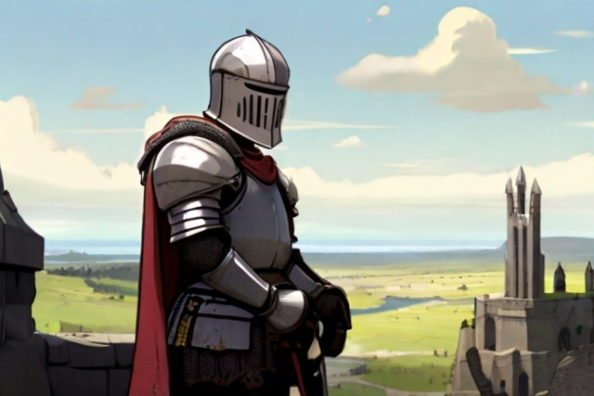

Sword master:
Unite
Cost: 4 gold
Attack: 40
Health: 200
Text: This unite moves slow
Sitat: No blade in my hands are ever dull
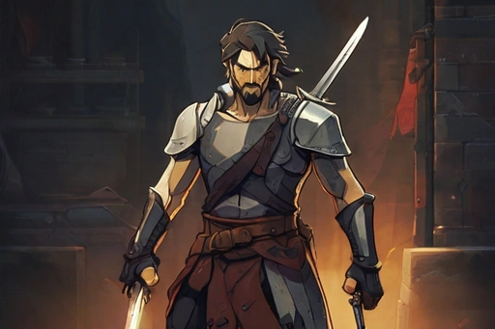
Taveren:
Tower
Cost: 4 gold
Health: 500
Text: Bosts attack, health and attack speed with 10%, Reduces movement speed with 20%
Sitat: A good war needs good boose
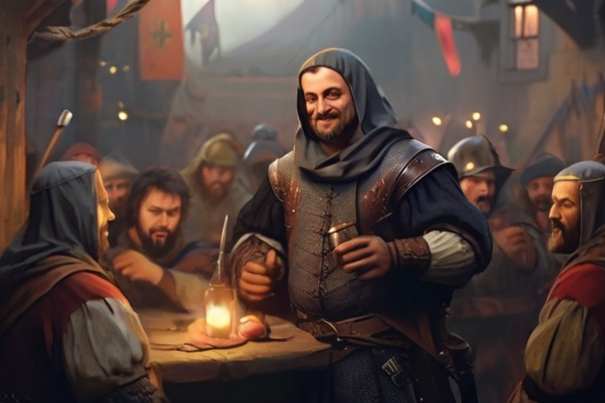

Sword apprentice:
Cost: 2 gold
Attack: 10 - 40
Health: 100 - 200
Text: Grows into a sword master through
(hvis han har gått 1 lengde har han 40 og 200 i stat)
Sitat: I will grow strong
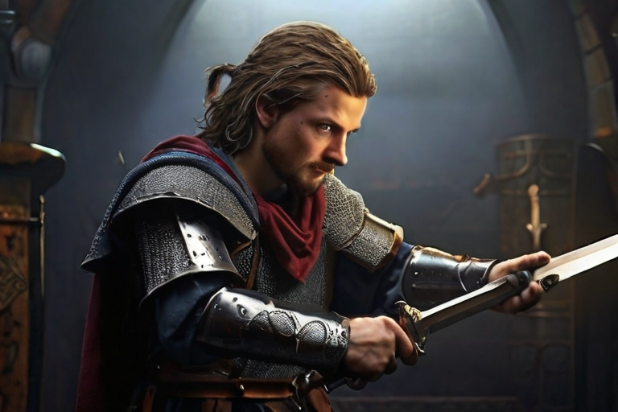
War eagle:
Cost: 3 gold
Attack: 10
Health: 100
Text: Can only be attacked by range unites
Sitat: Kaka
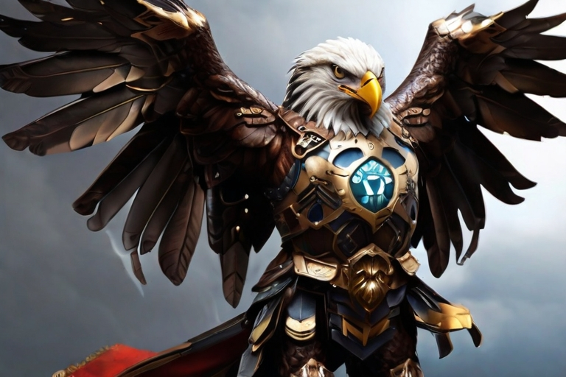

Wizzard:
Cost: 5 gold
Attack: 50
Health: 200
Text: Range attack
Sitat: Fireball!


Elf warrior:
Cost: 2 gold
Attack: 10
Health: 100
Text: Range unite, attacks fast
Sitat: In the name of nature
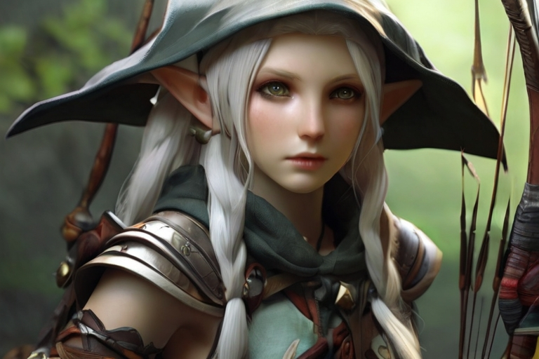
Archer:
Cost: 2 gold
Attack: 20
Health: 100
Text: Range unite
Sitat: I never miss


Catapult:
Cost: 4 gold
Attack: 10
Health: 200
Text: Damage is multiplied by 10 if it attacks a tower.
Sitat: knirk knirk
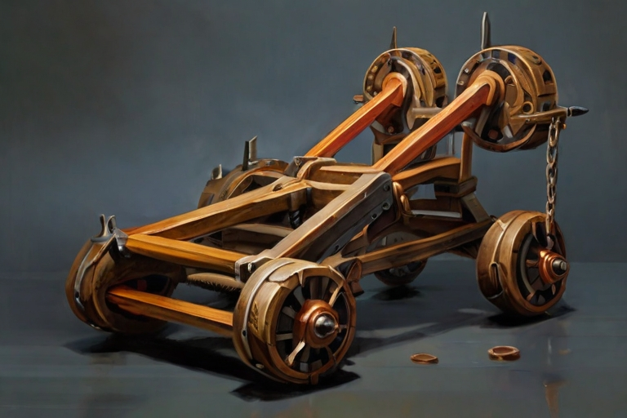
Guardian:
Cost: 5 gold
Attack: 20
Health: 300
Text: Absorbs damage from those around him
Sitat: I will protect you
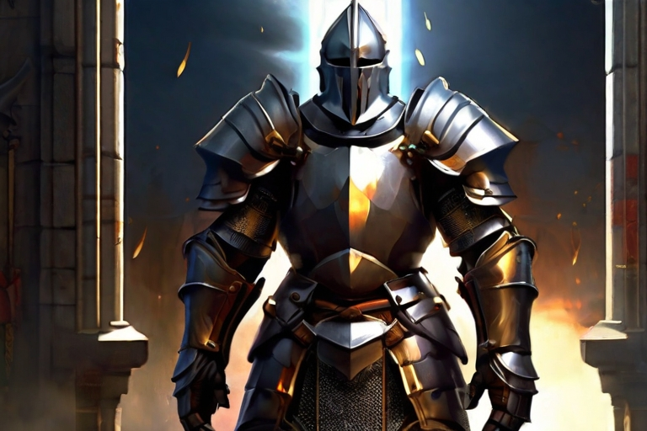

Trading place:
Tower
Cost: 5 gold
Attack: 0
Health: 300
Text: generate 1 gold every 10 sek
Sitat: It is only good business here
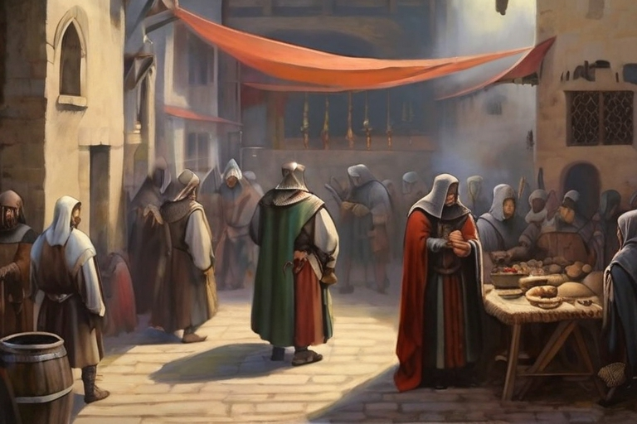
Secret tunnel:
Tower
Cost: 3 gold
Attack: 0
Health: 400
Text: Unites can spawn here
Sitat: I found a shortcut
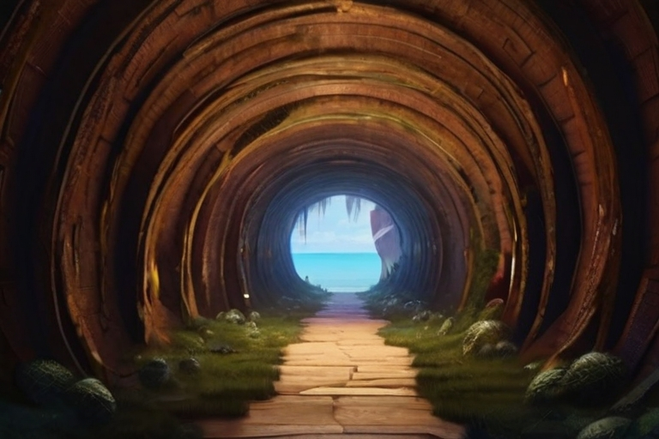
Tower:
Tower
Cost: 3 gold
Attack: 10
Health: 500
Text:
Sitat: Protect the tower!
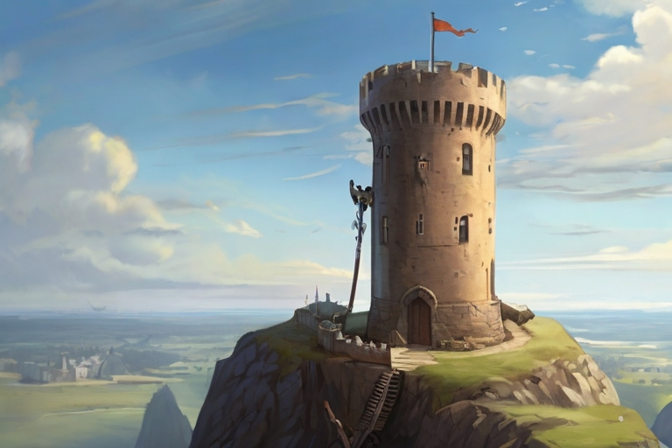
Dragon:
Unite
Cost: 7 gold
Attack: 40
Health: 400
Text: Can only be attacked by range unites
Sitat: Arrrr
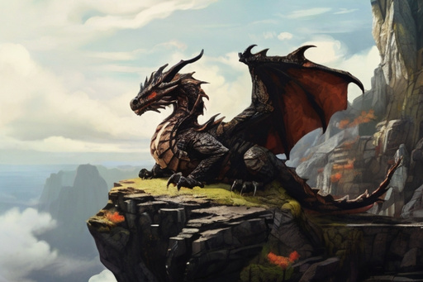
Meteor:
Spell
Cost: 8 gold
Attack:
Text: Destroy a tower
Sitat: Kabom
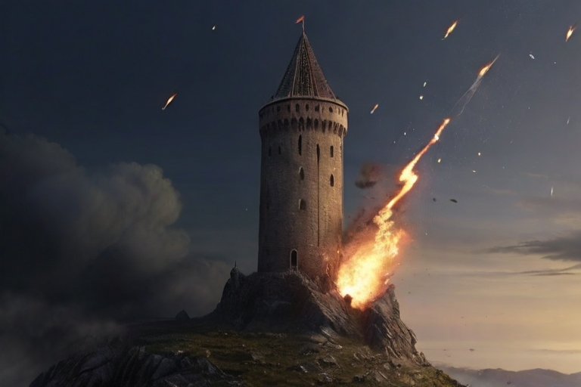
Demon Wolf:
Unite
Cost: 3 gold
Attack: 20
Health: 200
Text: Fast unite
Sitat: Kill!
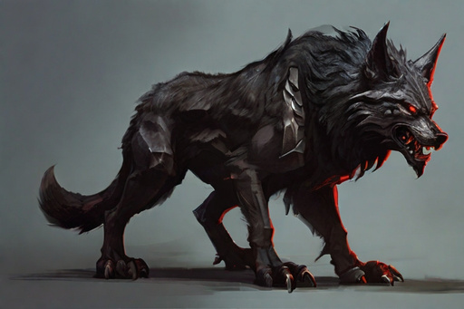
Farmer boy:
Unite
Cost: 0 gold
Attack: 5
Health: 100
Text:
Sitat: Protect the crops

Sword saint:
Unite
Cost: 5 gold
Attack: 30
Health: 300
Text: Fast movement speed
Sitat: For glory
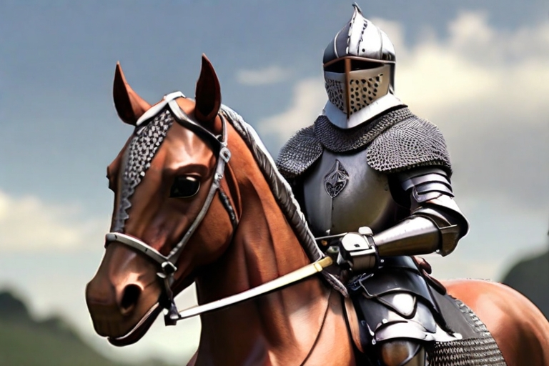
Sword saint:
Unite
Cost: 7 gold
Attack: 60
Health: 300
Text:
Sitat: I am the sword in my hands
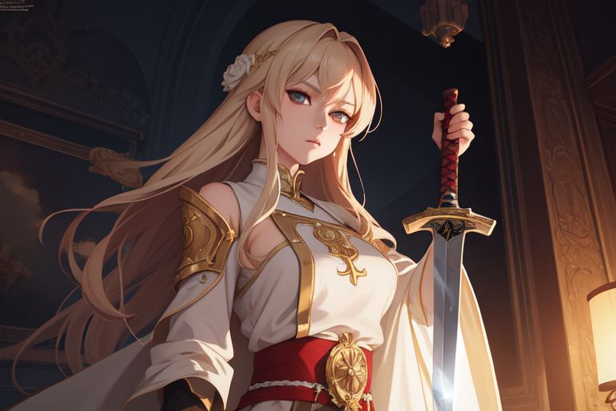
Brotherhood:
Unite
Cost: 4 gold
Attack: 4 x 10
Health: 4 x 100
Text:
Sitat: We will die for each other
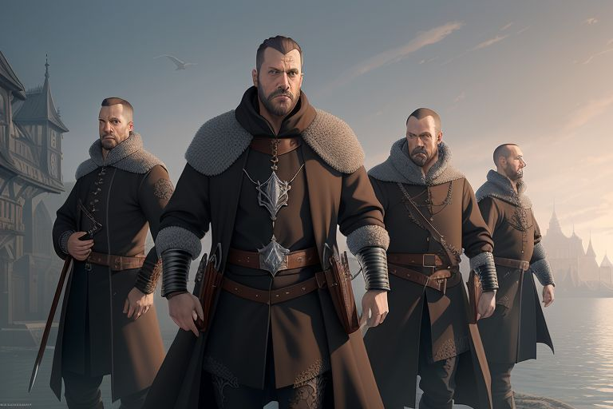
Martial art gym:
Tower
Cost: 5 gold
Attack: 0
Health: 300
Text: Spawns a martial artist every 20 sek
Sitat: Fighting for inner peace
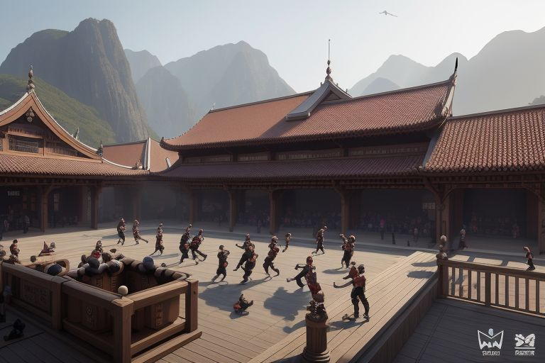
Martial artist:
Unite
Cost: 3 gold
Attack: 30
Health: 200
Text:
Sitat: I am both ying and yang
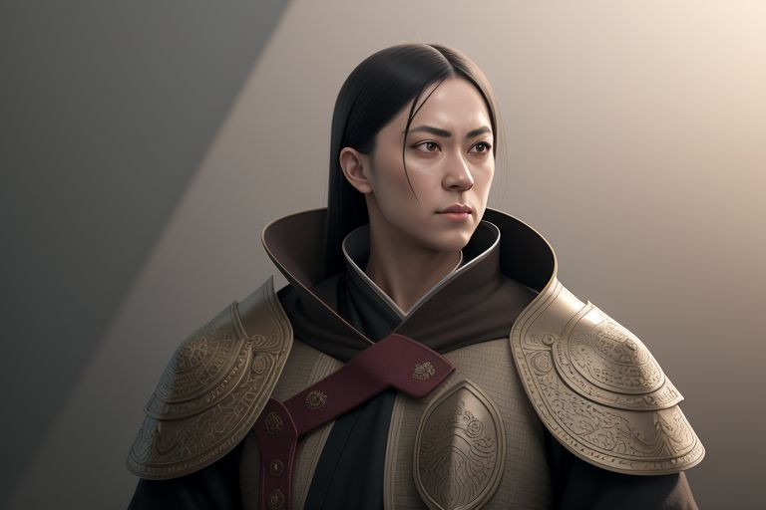
Castle:
Tower
Cost: 8 gold
Attack: 30
Health: 1000
Text: Takes longer to build
Sitat: This will keep them out


